PRESS RELEASE

BAUMIT LIFE CHALLENGE 2021
Baumit awarded the best facades of Europe

Vienna / Wopfing, April 2021 - When the largest color system for the facade "Baumit Life" was introduced in 2012, Mag. Robert Schmid (CEO Baumit Group and owner representative, Schmid Industrieholding) wanted to raise awareness among his employees about how Baumit materials are the foundation of homes for many generations and put architectural design and craftsmanship into the spotlight: The Baumit Life Challenge was born!

Today, the Life Challenge as an international competition with all of its submitted projects is synonymous for the perfect collaboration between Baumit, architects, investors and – above all – the executing industry.

In order to expand the design options on the facade to infinity, the Baumit Life color system offers 888 facade colors. With Baumit CreativTop every conceivable texture and almost every design is possible. For the perfect purist look architects and designers can now choose among 12 new white tones since the new color pallet “Shades of White” was introduced in early 2021.

The planned award ceremony of the Baumit Life Challenge in Valencia in spring 2020 has been postponed several times due to Corona. As the situation has not gotten any better a year later, the award for the most beautiful facade in Europe was rescheduled online via live stream.

“The Baumit Life Challenge 2020/21 set a new record despite the times we live in: 385 entries from 26 countries were submitted. Thanks go to all participants, Baumit partners and employees as well as the international expert judges. They are the ones who made the event possible.” says Robert Schmid enthusiastically.

Out of 36 nominations from 16 countries the architects' jury selected the project MO Museum in Vilnus by “Studio Libeskind” and “Do Architects” as the Life Challenge 2021 Award winner. In addition to the golden trophy for the main prize, the winning country also expects prize money of € 6,600. In addition, another 6 countries are looking forward to winning one of the categories with prize money of € 3,300 each.

The European facade of the year 2020/21:
An overview of the winners

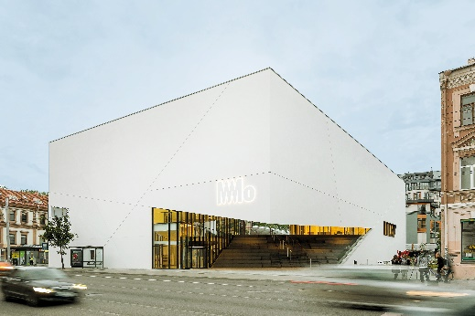
Life Challenge Winner
Life Challenge Award 2020/21:
Mo Museum, Vilnius (LT)
https://int.baumit.com/lifechallenge2020/projects/non-residential/2216/mo-museum

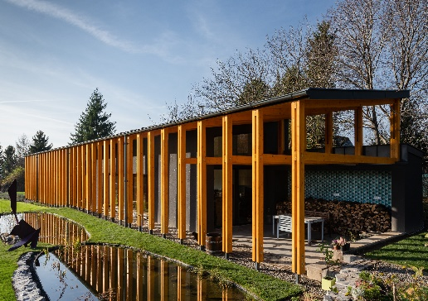
Single Family House
Longitudinal-Axis Home, Budakeszi (HU)
https://int.baumit.com/lifechallenge2020/projects/single-family-house/2378/longitudinal-axis-house

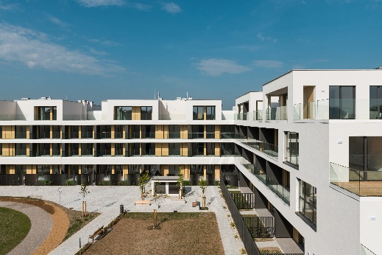
Multi Family Residential
Murgle Apartments, Ljubljana (SI)
https://int.baumit.com/lifechallenge2020/projects/multi-family-residential/2574/murgle-apartments

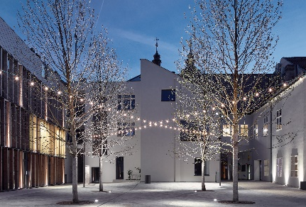
Non-residential
The Courtyard, Trnava (SK)
https://int.baumit.com/lifechallenge2020/projects/non-residential/2708/the-courtyard

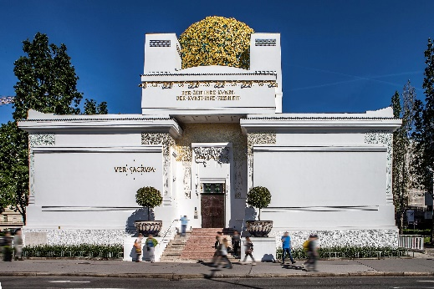
Thermal Renovation
Secession, Wien (AT)
https://int.baumit.com/lifechallenge2020/projects/historical-renovation/2346/secession

The European facade of the year 2020/21:
An overview of the winners

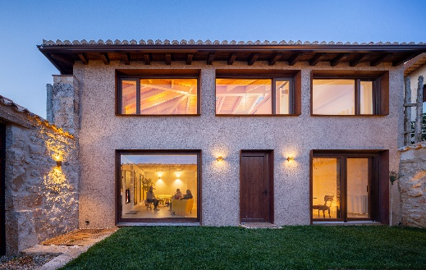
Historical Renovation
Vivienda Alcoba, Alcoba de la Torre (ES)
https://int.baumit.com/lifechallenge2020/projects/thermal-renovation/2704/vivienda-alcoba

Stunned by Texture
Rue Curial, Paris (FR)
https://int.baumit.com/lifechallenge2020/projects/stunned-by-texture/2736/rue-curial

About Baumit
Baumit was founded as a building materials brand in 1988 and is now an established force in the European building materials industry. Baumit is a leading manufacturer of thermal insulation composite systems (ETICS) and top coatings for facades in Central Europe. The company produces more than 45 million square meters of thermal insulation every year – a good reason to trust the high-quality and versatile insulation materials from Baumit. The Baumit Group has branches and subsidiaries in 25 European countries. Baumit employs more than 3,500 people and achieved sales of 1 billion euros in 2020.

Attachments/Download:

1. Robert Schmid.jpg:
- Mag. Robert Schmid, CEO Baumit Group and owner representative, Schmid Industrieholding
(photo credit: Baumit)

2. PR LC 21 winner photos.zip:

- 01 MO Museum_LC21 Award.jpg: Mo Museum in Vilnius, LT (photo credit: Norbert Tukaj)

- 02 Longitudial-Axis Home_Single Family.jpg: Longitudinal-Axis Home in Budakeszi, HU (photo credit: Benedek Bognár)

- 03 Murgle Apartments_Multi Family.jpg: Murgle Apartments in Ljubljana, SI (photo credit: Žiga Lovšin)

- 04 The Courtyard_Non Residential.jpg: The Courtyard in Trnava, SK (photo credit: BoysPlayNice)

- 05 Secession_Historical Renovation.jpg: Secession in Wien, AT (photo credit: Baumit)

- 06 Vivienda Alcoba_Thermal Renovation.jpg: Vivienda Alcoba in Alcoba de la Torre, ES (photo credit: Rubén Bescos)

- 07 Rue Curial_Stunned by Texture.jpg: Rue Curial in Paris, FR (photo credit: FABPICTURE)

More information:

lifechallenge.baumit.com
baumit.com

Press Contact:

Günter Neubacher
Head of Marketing
Baumit Group

Baumit Beteiligungen GmbH
2754 Wopfing 156, Austria

Tel. +43 (0) 501 888 – 1112
g.neubacher@baumit.com
www.baumit.com

