“Market in Pécs” Triumphs: Europe’s Most Beautiful Façade of 2024

In a celebration of architectural excellence, the winners of the Life Challenge Award were unveiled in Ljubljana on May 23, 2024. An international jury of experts voted for the best facade and awarded six category winners from among over 300 submissions. At a grand event with around 500 guests, the most beautiful façades from across Europe were honored.

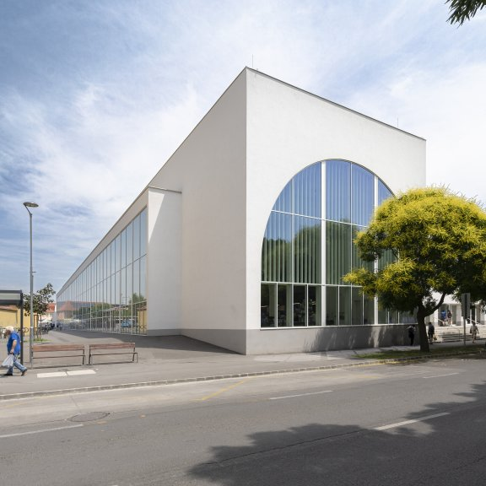
Market in Pécs, Hungary: The winner of the Life Challenge 2024

Ljubljana/Wopfing, May 2024 – architects, construction companies, and investors gathered on May 23, in Slovenia’s capital for the Baumit Life Challenge Award Ceremony. This edition marked the tenth anniversary of the event, making Ljubljana a fitting host city where the winning project from the previous challenge — the iconic Cukrarna Gallery – is located.

This prestigious title “Baumit Life Challenge Winner 2024” was bestowed upon the winning project, ‘Market in Pécs’ which surpassed all expectations with its innovative design and unique features. Chosen from the shortlisted projects across all six categories, the ‘Market in Pécs’ project represents the peak of architectural excellence. It pays homage to the rich history of Pécs, a Mediterranean city in Hungary that was once a Roman settlement.

This project masterfully blends stylistic elements from the Roman basilica and Oriental bazaar, creating a truly distinctive architectural experience. The design features elegant arches and a slender structure with one side entirely made of glass, reminiscent of a basilica's grandeur. This harmonious fusion of historical and cultural influences not only enhances the aesthetic appeal but also serves as a functional, bustling hub for the people of Pécs.

Beyond the overall Life Challenge winner, the grand event celebrated the most beautiful façades in six distinct categories: Single Family House, Multi-Family Residential, Non-Residential, Thermal Renovation, Historical Renovation, and Stunned by Texture. Each category showcased different aspects of architectural brilliance, from innovative residential and public buildings to sustainable renovations and meticulous historical restorations.
13 European jury members had the challenging task of choosing the best façades by evaluating design, appearance, and workmanship, but they also weighed criteria such as the use of resource-saving materials, sustainability, and social impact.

Category Winners
The jury selected those brilliant six projects as winners in their respective categories:

- Single-Family House
Carnation Street 4, Lithuania
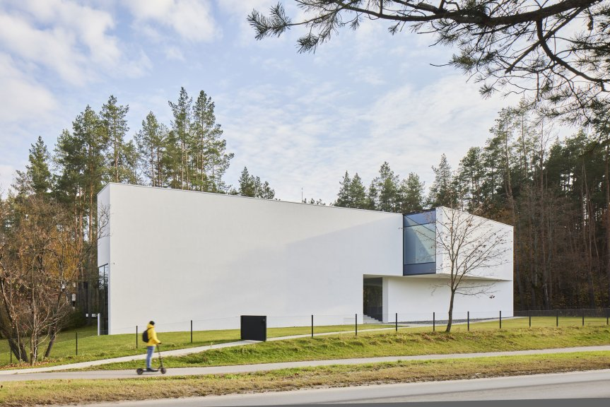
- Multi-Family House
NSA13 “TWPEAKS”, Spain
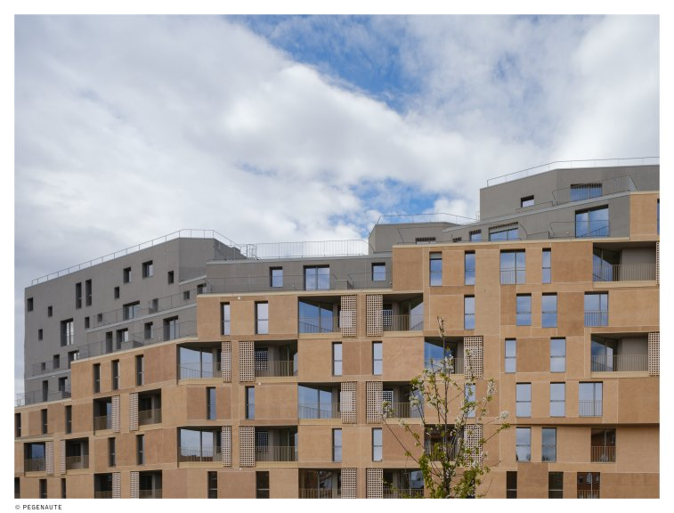

- Thermal Renovation
Moxy Kaunas Center, Lithuania
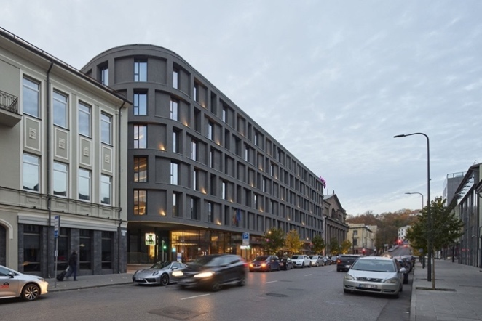
- Historical Renovation
Children’s Hospice Caritas, Poland
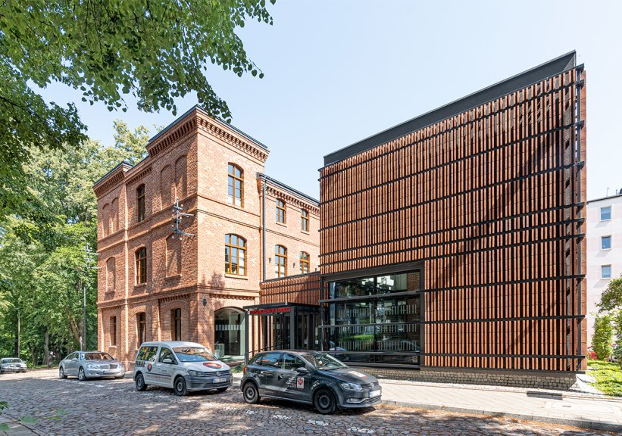
- Stunned by Texture
VINO.TAKE, Austria
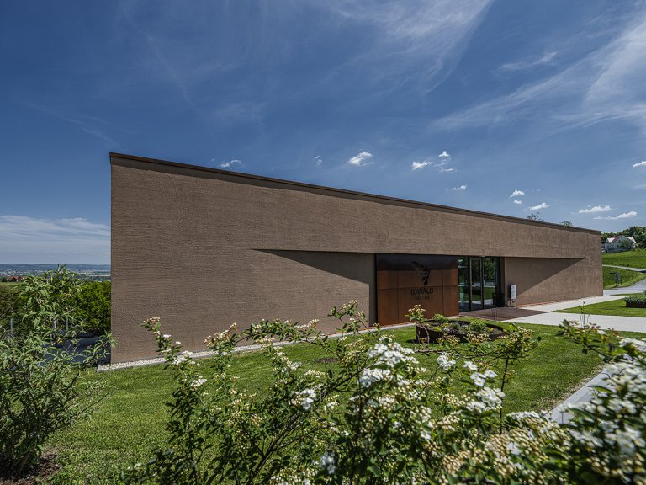
- Non-Residential
Kindergarten among Mountains, Slovenia
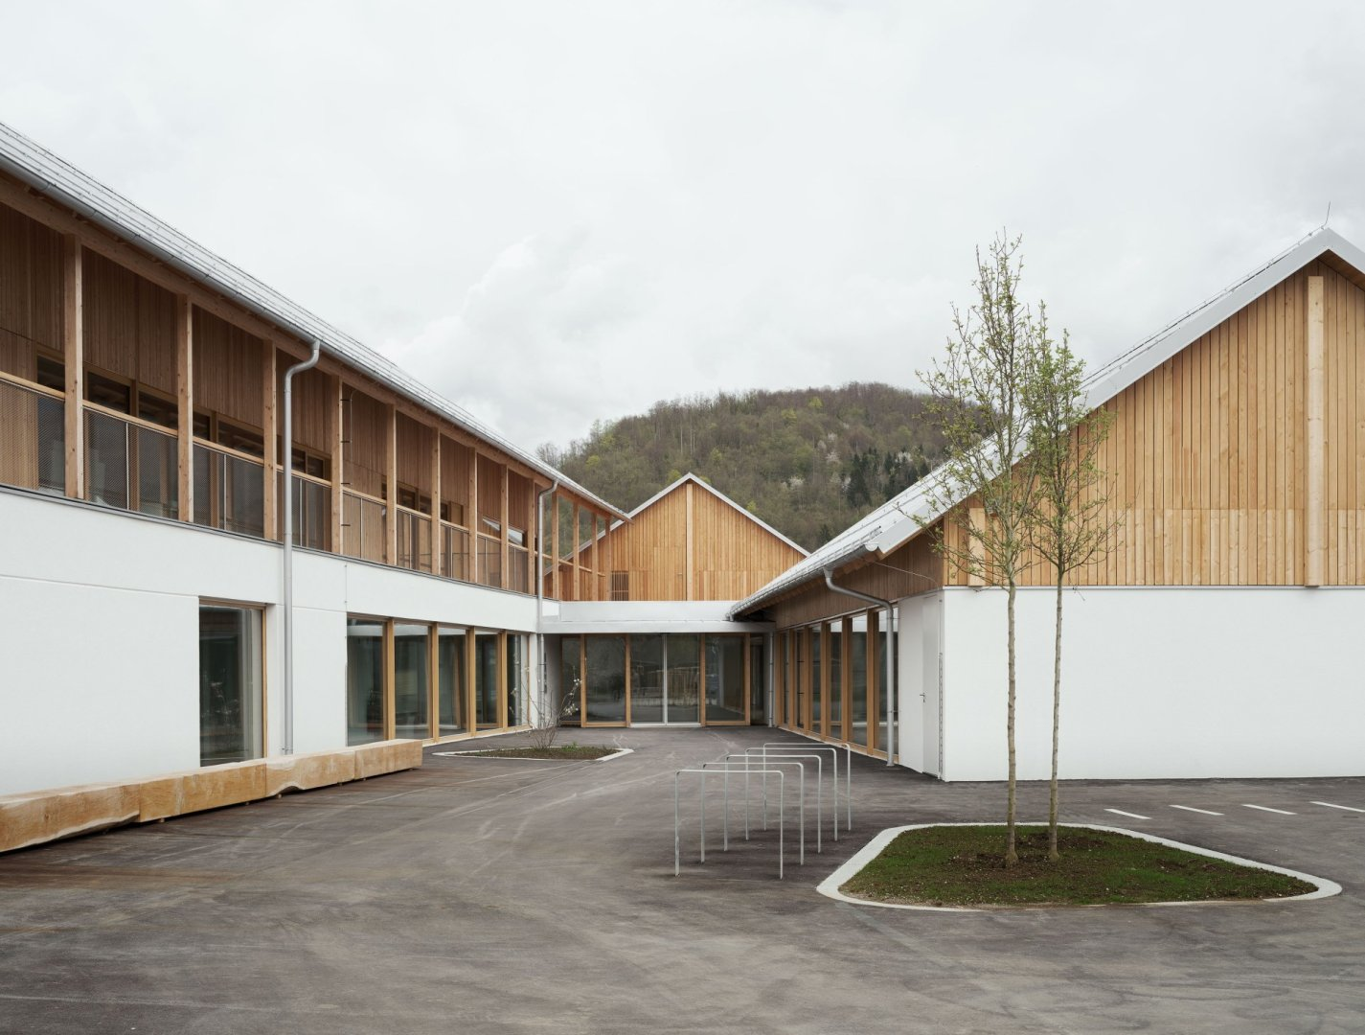

Robert Schmid, CEO and owner representative of the Baumit Group, expressed his heartfelt gratitude and excitement at witnessing the remarkable projects showcased across such diverse categories. He emphasized his deep appreciation for the ingenuity and craftsmanship that these architects and constructors brought to the table, transforming the built environment with their innovative façades. Personally, congratulating the overall winner "Market in Pécs”, Schmid highlighted their achievements as perfect combination of innovative façade design and tradition. This project perfectly illustrates the blend of imagination and craftsmanship that Baumit champions.

The Baumit Life Challenge has evolved into a prestigious international competition, celebrating architectural creativity and pushing the boundaries of façade design. As applause echoed through the venue, representatives from numerous Baumit countries joined the celebration, each proudly claiming victory in their respective categories. The event continues to be a beacon of inspiration, fostering a European community dedicated to advancing architectural excellence and sustainable design.

